Survey App Functionality

1. The codebase is split into server and client folder. Client folder houses the React based code for the UI and the server contains backend functionality.
2. At first execution, the questions are extracted from csv file and a MongoDB database collection ‘questions’ from where we can do subsequent query.
3. 10 Survey questions are selected at random and displayed to the End user.

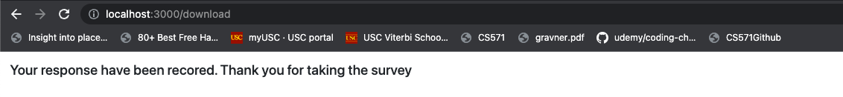

1. All back end calls are Restful in nature. Submit button will trigger a post call and responses are recorded in the MongoDB collection ‘responses’.

Responses stored using just the basic fields. More could be included but I filtered it down for this Proof-of-Concept.

Expanding the node Array

1. Download CSV Reports button is given on the landing page for the lack of a better place. This is the format of the stored results.



The Survey responses are flattened and then converted to csv. Each survey question response field is prefixed with the question number in the survey. We have also recorded time for submission and create datetime. Question response can be obtained from the selectedoption field where 1= Strongly Disagree, 2=Disagree, … and so on.